You need to enroll in Multi-Factor Authentication (MFA) in order to e-Prescribe Controlled Substances (EPCS) in Epic. You will need a computer, internet connection, and your mobile phone to complete this task.
Complete the steps below to enroll in MFA for EPCS.
Steps
- Launch an internet browser and navigate to: https://myaccount.microsoft.com/
- Click the Security Info tile
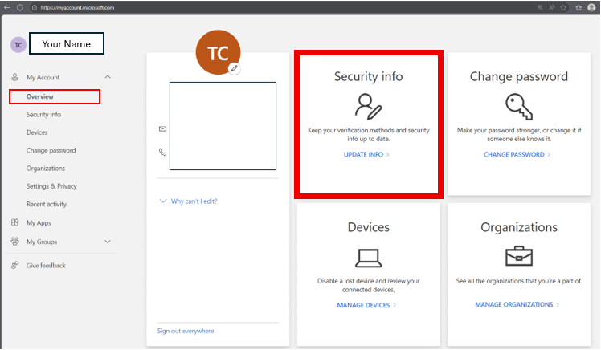
- If prompted, complete the authentication (Approve sign in request)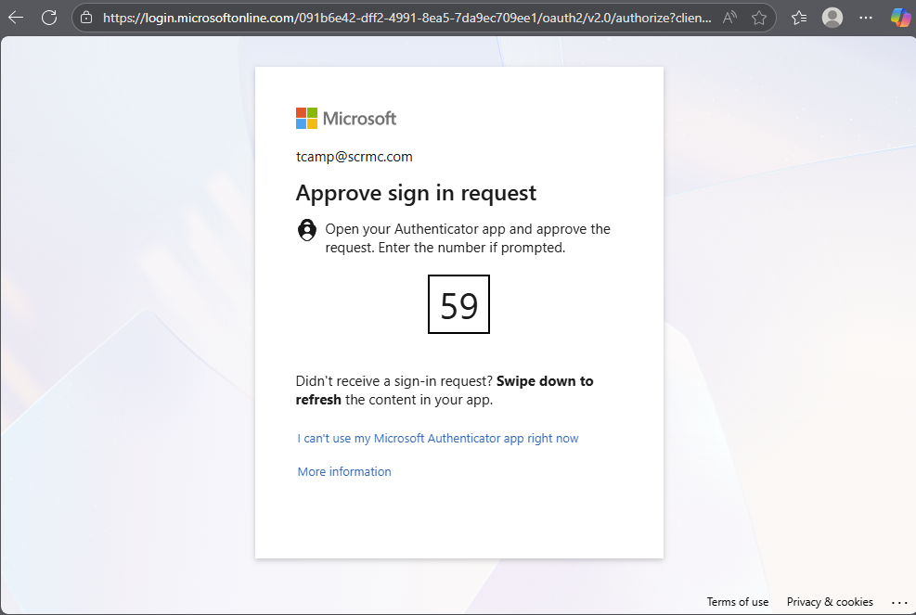
- Next, click Add a sign-in method
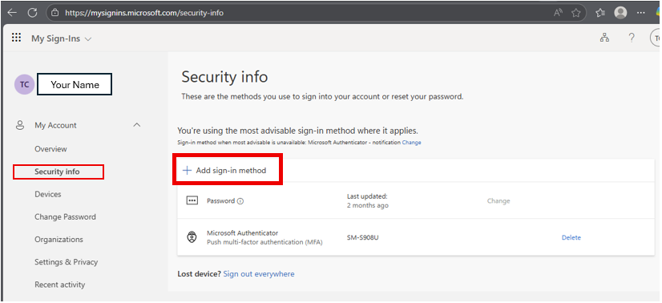

- The sign-in method required for EPCS is Microsoft Authenticator. Select the Microsoft Authenticator option from the list of sign-in methods.
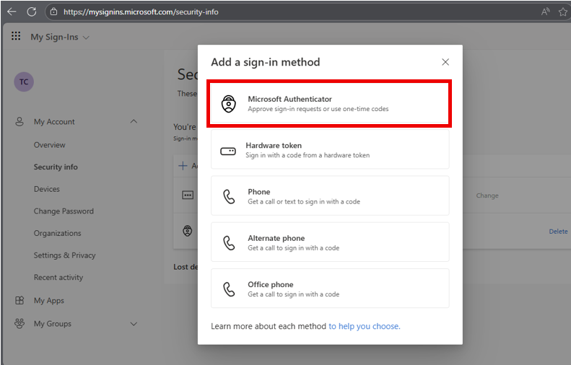
- Install the Microsoft Authenticator on your device from the Apple or Google application store
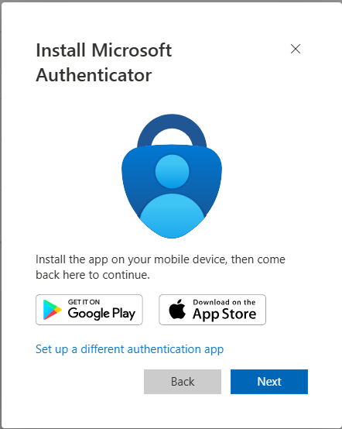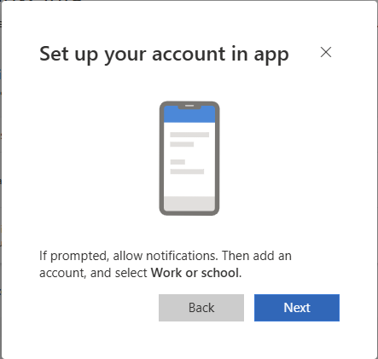
- Once the application is installed on your device, add (+) a new account within the application on the phone. Choose Work or School account.
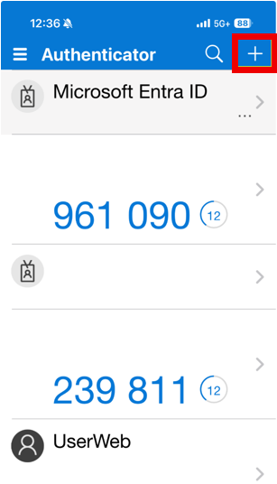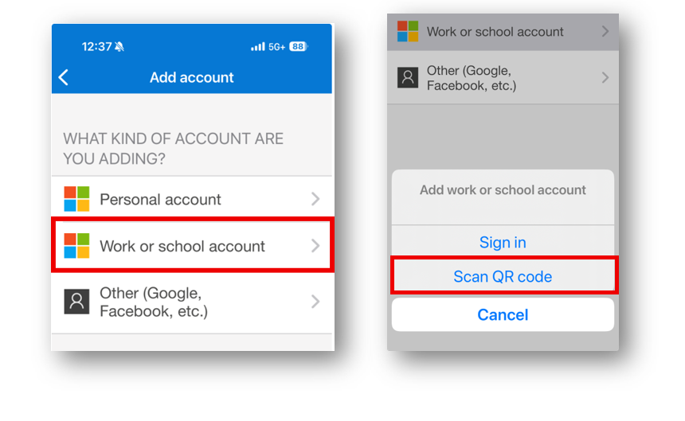
- Select the Scan QR code option. Then use your phone to scan the QR code on your computer.
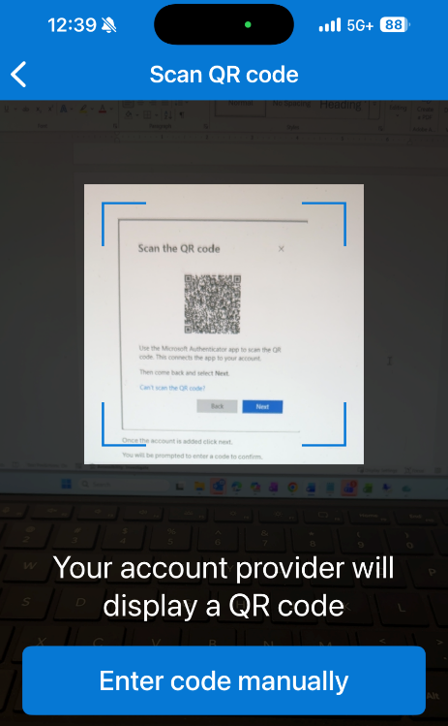
- After scanning the QR code and adding the account, click Next on computer screen and you will be prompted to enter the code on the screen into your Microsoft Authenticator app.
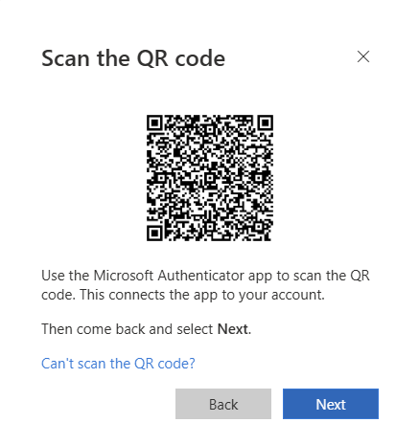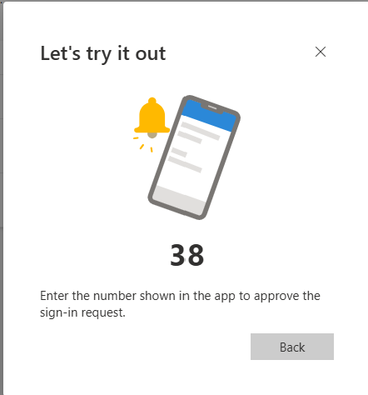
- Once the code is entered you have completed the enrollment!
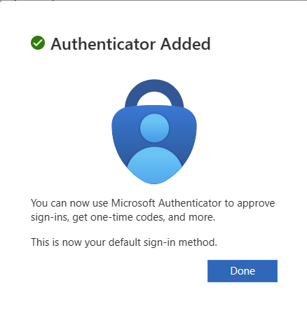

FAQ

The Microsoft Authenticator app is the one in the screenshot below w/ the green arrow - not the one with the 'X' through it (that's Google authenticator), which also comes up when a user searches "authenticator."

